Assignment 1
React Redux Toolkit — Shopping Cart with React + TypeScript
Contents
Assignment 1 1
Overview 1
Objectives 1
Deliverables 1
Functional Requirements 2
Product List 2
Cart 2
Cart Controls 2
Non-Functional & Technical Constraints 2
Project Structure 2
Starter & Run Instructions 3
Acceptance Criteria 3
Project Setup 3
Product List 3
Cart 3
Cart Controls 3
Constraints 3
Expected Output 4
Submission 4
App Screenshots 4

Overview
Build a small, single-page React application in TypeScript that demonstrates state management using Redux Toolkit. The goal is to practice slice creation, store setup, and component interaction with Redux state.

Objectives
Create a minimal React (TypeScript) app with a simple layout (header, main, footer).
Implement a shopping cart feature with the following components:
1) Product List — displays products with 'Add to Cart' buttons.
2) Cart — shows added items, quantities, and total price.
3) Cart Controls — allows incrementing, decrementing, and removing items.
Ensure type safety, accessibility, and clean structure/styles.

Deliverables
A React project containing:
• src/app/store.ts (Redux store setup)
• src/features/cart/cartSlice.ts (slice with reducers and actions)
• src/components/ProductList.tsx
• src/components/Cart.tsx
• src/components/CartControls.tsx
• src/App.tsx
• src/index.tsx
• src/styles.css (minimal styling)
A README with project name, setup & run instructions, and Node.js version used
Screenshots showing: product list, cart interactions, and total price updates

Functional Requirements

Product List
• Displays a list of products with name, price, and 'Add to Cart' button.
• Dispatches action to add item to cart.

Cart
• Displays items added to cart with quantity and price.
• Shows total price of all items.

Cart Controls
• Buttons to increment/decrement quantity.
• Remove item from cart.
• Uses useDispatch and useSelector hooks.

Non-Functional & Technical Constraints
• Framework: React with TypeScript
• State Management: Redux Toolkit
• No Networking: No API calls or data fetching
• Accessibility: Labels, aria attributes, readable contrast
• Styling: Single stylesheet, minimal and clean
• TypeScript: No any types; use correct types throughout

Project Structure
src/
app/
store.ts
features/
cart/
cartSlice.ts
components/
ProductList.tsx
Cart.tsx
CartControls.tsx
App.tsx
index.tsx
styles.css

Starter & Run Instructions
npm create vite@latest shopping-cart-demo -- --template react-ts
cd shopping-cart-demo
npm install @reduxjs/toolkit react-redux
npm start

Acceptance Criteria

Project Setup
[ ] React app compiles and runs.
[ ] Directory structure matches spec.
[ ] store.ts sets up Redux store correctly.

Product List
[ ] Displays products with 'Add to Cart' buttons.
[ ] Dispatches add action on button click.

Cart
[ ] Displays items with quantity and price.
[ ] Shows total price.

Cart Controls
[ ] Increment/decrement buttons work.
[ ] Remove button works.
[ ] Uses useDispatch and useSelector.

Constraints
[ ] Only Redux Toolkit used.
[ ] Accessibility: labels, aria attributes.
[ ] TypeScript types correct.
[ ] Code is clean and documented.

Expected Output
Include screenshots showing:
• Product list with 'Add to Cart' buttons.
• Cart with items and total price.
• Cart controls in action.

Submission
Share a README with:
• Node version
• Setup & run steps
• Notes on decisions
• Screenshots of all components

App Screenshots
Provide whatever styling you choose
Your app should look something like this=>
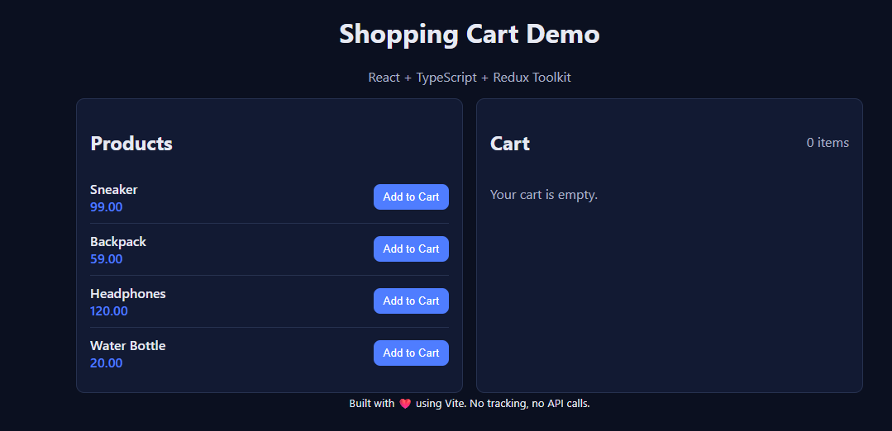
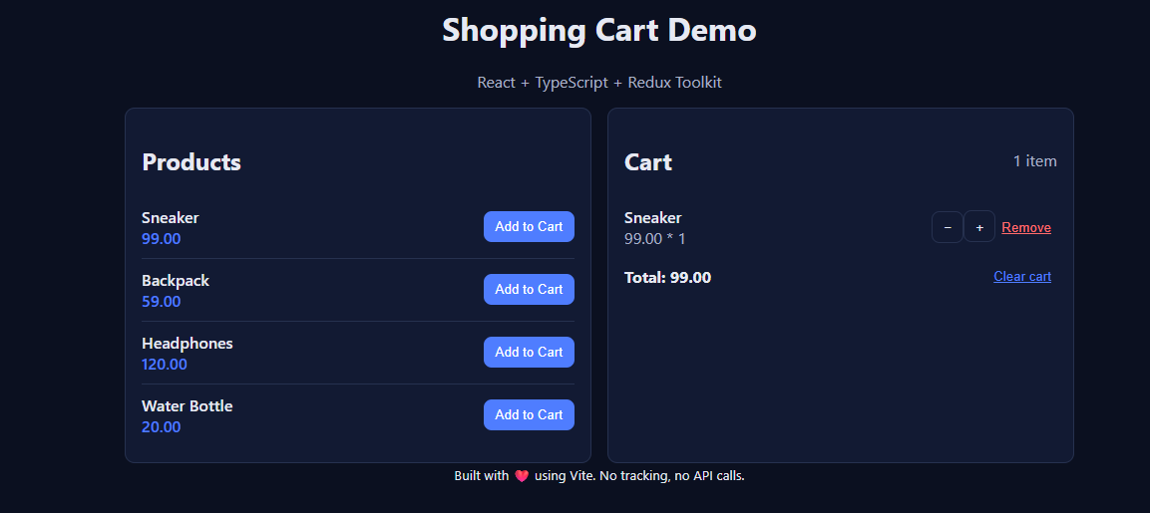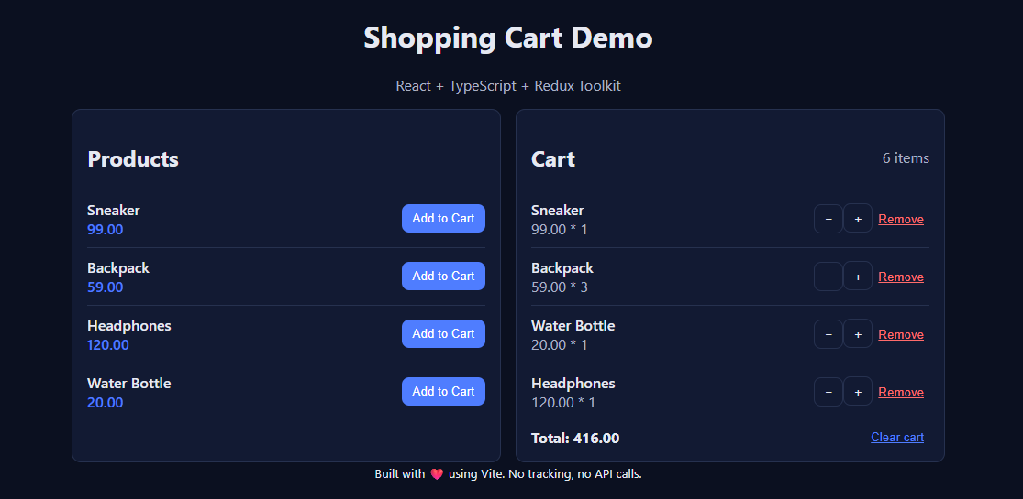
On clicking “Clear cart”=>



